**Task 1**

**Introduction -**

This document will demonstrate the development of Cloud Computing answers the use of carrier company’s frameworks and open source equipment. it's going to also configure a Cloud Computing platform with a cloud carrier issuer’s framework. it's going to also implement a Cloud platform and the usage of open supply gear. This document will analyse the technical demanding situations for cloud applications and verify their risks by means of analyse the most not unusual problems which stand up in a Cloud Computing platform and talk appropriate answers to these problems and investigate the maximum commonplace safety issues in cloud environments.

**Create two VMs (Linux and Windows) from the Azure Portal by using an Azure Marketplace images -**

**Resource Groups -**

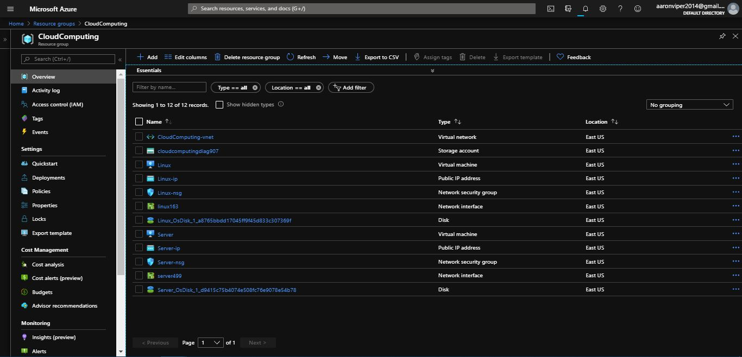

**Kali Linux Virtual Machine -**

**Kali Linux VM Deployment process -**

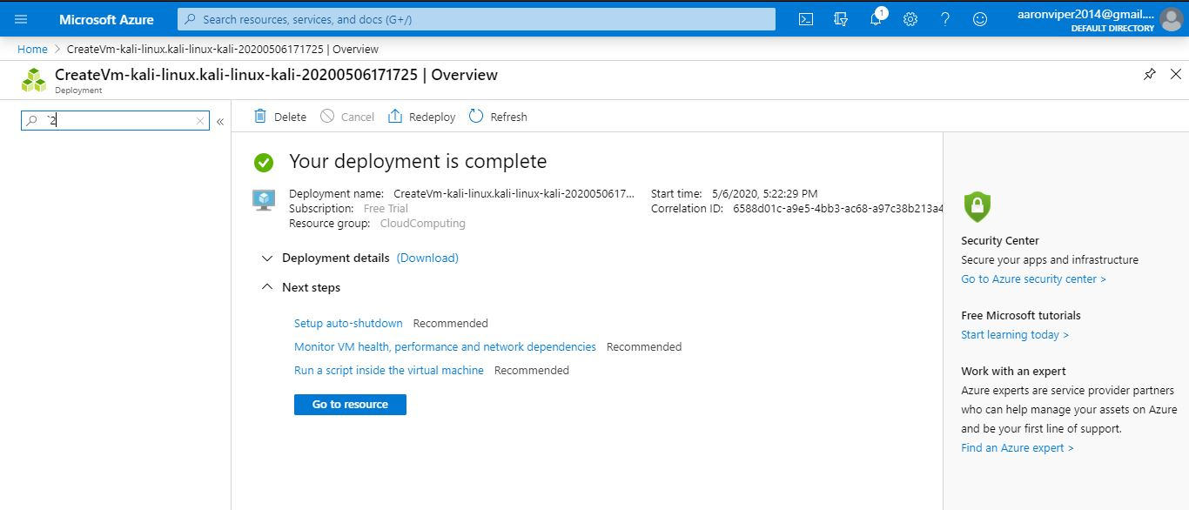

**Kali Linux VM settings -**

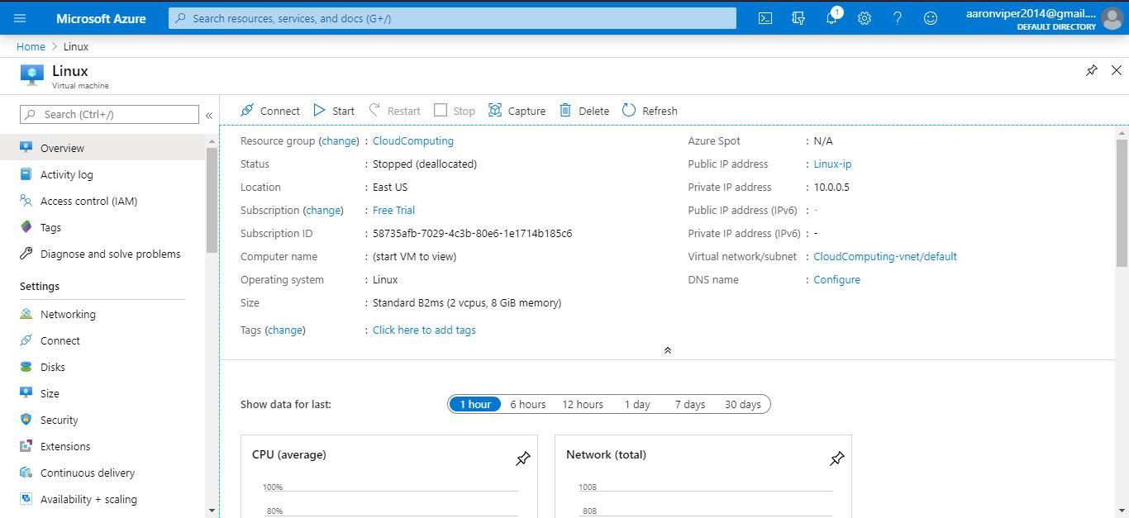

**Windows 10 Pro Virtual Machine -**

**Deployment process for Windows VM -**

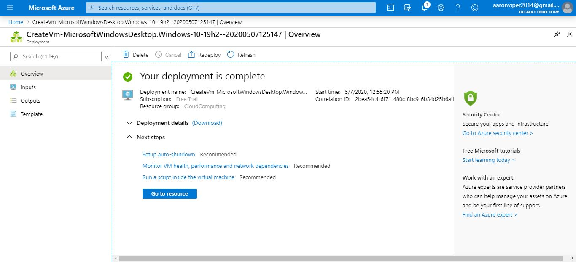

**Windows 10 pro VM Settings -**

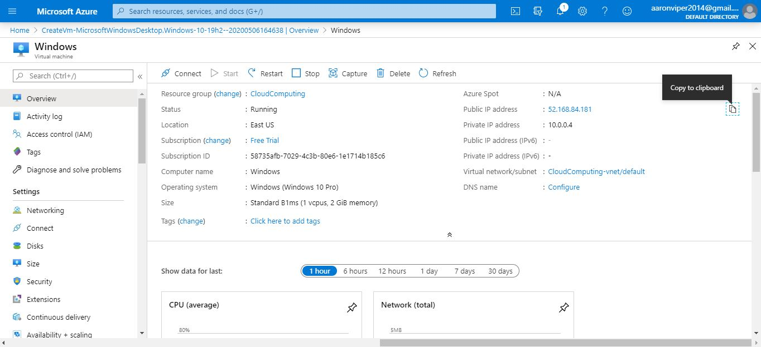

**Verify the functionality of the VMs**

**Kali Linux PuTTY Configuration -**

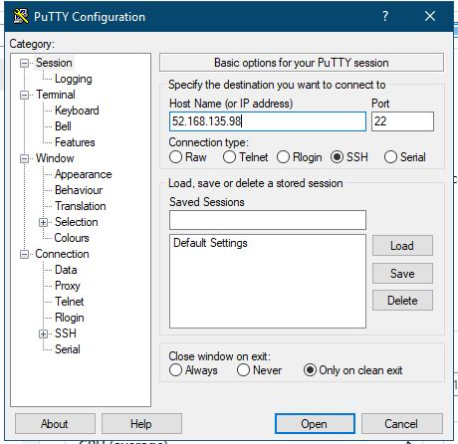

**Kali Linux Terminal login -**

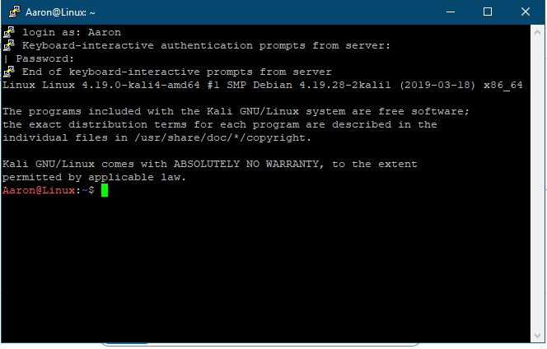

**Windows 10 pro VM Start up / Login Testing -**

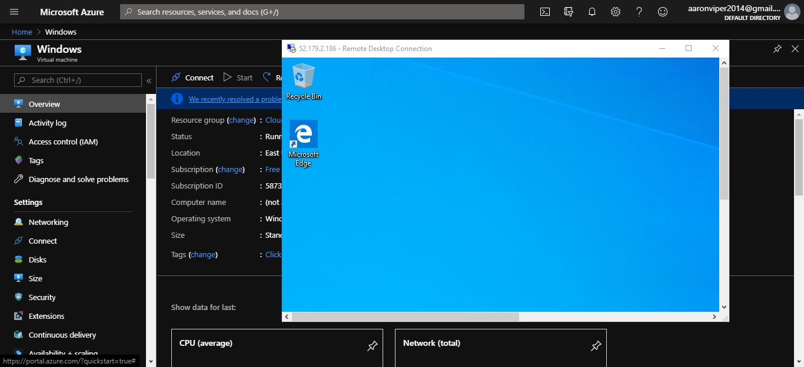

**Analysing the most common problems in creating the VMS and their associated resources, e.g. Disks, Networking, management, Tags, etc. (at least 6 problems) and discussing appropriate solutions for them.**

Below are 6 problems with solutions to each which discuss the most common problems in creating VMS -

**1. VM drains precious processing power -**

Companies additionally virtualize a number of workloads after which select to buy new devices down the road to house more workloads. it is due to the fact companies normally do not have business plans in location to agenda or take care of VM boom. Before virtualization, the virtual machine took weeks to deploy due to the fact businesses had to plan the machine price range and coordinate the roll-out. transferring a clean assignment online turned into a huge problem that IT specialists and executives had been looking at. With virtualization, the hypervisor has to allocate the disc area and, in mins, build a brand new VM to the open application.

**Solutions -**

Due to the fact VMs are simple to build and put off, businesses require policies and protocols which can assist them understand why they need a brand new VM, decide how long they need it, and give an explanation for it as if it have been a new server. companies also can propose tracking VMs with lifecycle management software programs. specific evaluation dates and withdrawal dates may be identified such that the employer can also either amplify or put off.

**2. VMs interfere with the network by creating traffic -**

Congestion of the community is another common challenge. For starters, an organisation that often operates the gadget numbers might discover that it has enough ram and CPU cores to reside 25 VMs on a single server. maximum servers most effectively have a single NIC connexion, so it does not take lengthy for network traffic on a virtualized device to overload the NIC. network latency-sensitive workloads can file errors or maybe crashes.

**Solution -**

Universal Gigabit Ethernet ports may additionally commonly deal with visitors from several VMs, however corporations considering large enlargement costs need to replace several NIC ports to have sufficient community bandwidth. organizations may alleviate quick-term network congestion problems with the aid of rebalancing workloads to distribute bandwidth-hungry VMs through several servers.

**3. Possible server Hardware failures -**

If 10 VMs which are each running at the identical bodily disc. Virtualization offers resources, which include snapshots and stay replication, that can comfort VMs and make certain their non-stop activity underneath regular circumstances. yet virtualization does little to comfy the gadget in the back of it. ok, what occurs when the pc fails?. The actual hardware tool is a not unusual factor of failure which influences all of the workloads working on the community. better consolidation quotes mean higher workloads on each system, and device mistakes affect the ones workloads. it's far really awesome from traditional bodily implementations in which one programme was served by an unmarried server.

**Solution -**

There are a range of strategies to minimise device hardware screw ups. Throughout the quick time period, corporations can favor redistribute workloads to avoid several important programmes from dwelling on an unmarried server. It can also be feasible to lower consolidation levels in the quick time period to be able to restrict the wide variety of workloads on every physical machine. Those utility hardware abilities assist avoid or at the least maintain errors from being catastrophic. The maximum essential workloads may be on server clusters, which preserve numerous copies of every workload in synchronisation. when one processor crashes, another node within the cluster can take over and proceed to run without interruption.

**4. Lack of performance in Virtual Machines -**

Businesses who plan to switch their 25-year-antique custom-written company database server to a VM that notice that the database plays slower than expected. Or if businesses want to virtualize a current programme, they will locate it's far risky or slow. there are numerous alternatives on the subject of VM safety problems.

**Solution -**

If the generation in question is new or vintage, checking out in a laboratory placing prior to virtualization will assist detect problematic apps and offer businesses the capability to devise solutions to virtualization troubles until they carry out the VM into action.

**5. Software licencing for Virtual Machine -**

Software program licencing has regularly been complicated and pricey, however software program companies are an increasing number of preserving up with virtualization technologies and converting their licencing legal guidelines to catch up on VMs, severa CPUs and other aid availability holes that virtualization calls for. The bottom line is that corporations can not desire to copy VMs without buying licences for the OS and the VM software program. Licensing infringements can be liable to civil lawsuits by way of businesses and to substantial fines. massive software businesses frequently assert the freedom to audit and verify their authorising organizations.

**Solutions -**

Vendors are extra interested in obtaining licencing charges than in prosecutions, specifically for first-time offenders. The virtualization of servers has changed the design of latest business computing. It permits the green utilization of computing assets on smaller bodily gadgets and offers good enough methods of storing facts and ensuring availability. but virtualization isn't simple and increases sparkling problems that firms need to comprehend and tackle so one can maintain the facts centre going for walks smoothly.

**6. Outdated VMware Tools that may not be installed -**

The biggest famous problem with a digital computer is that VMware software is either not installed or obsolete. VMware software program is a collection of programs intended to optimise the overall performance of a bunch of working devices on a digital pc and raise the capability to operate a virtual machine. For each up to date release, VMware often enhances VMware software, and directors will proactively upgrade applications for each digital device in order to obtain the benefits of the ultra-modern functionality offered by VMware.

**Solution -**

Identifying that you have a digital pc or devices that are obsolete or now not hooked up is straightforward to do. The virtual machine assessment tab shows the state of the VMware software on that precise virtual gadget. putting in or upgrading VMware tools is completed easily through the Cloud Server. This installation or improvement does not even involve a reboot of the host software program on the virtual system.

**Assessing how Azure Portal can protect your Virtual Machines from viruses and malware.**

This section will be discussing the core security features of Azure that can be used with virtual machines.

Azure digital computer systems might be utilized to actualize an extensive assortment of programming advancements in a coordinated manner. This product consists of Microsoft home windows, Debian, Microsoft square Server, Oracle, IBM, SAP and Azure BizTalk applications. you can run any closing mission at hand and language on for all intents and purposes every running framework. Azure virtual gadget allows you the straightforwardness of virtualization without the want to purchase and address the genuine hardware operating with the virtual computer. you'll create and send your product with the certainty that the statistics is sheltered and ensured in profoundly comfy server farms.

Azure gives the important security includes that advantage us by -

* Meeting prerequisites that fundamental
* Giving secure system traffic
* Information encryption for delicate data
* Risk location and recognizing
* Assurance from malware and infections for virtual machines

**Giving private Computing highlights -**

At the same time as private figuring is not in fact a part of digital machine safety, the difficulty of virtual gadget protection is an extra elevated stage challenge of "computer" safety. mystery processing has an area with the collection of "records'' assurance. secret calculation means that while "unfastened" statistics is required for gifted creation, the records is made certain approximately inside a honest Execution environment https:/en.wikipedia.org/wiki/relied on execution circumstance (TEE-otherwise known as an enclave), a sign of which is determined in the discern below. TEEs make sure that it's in reality impossible to get to facts or physical games from outside, aside from with a debugger. They likewise guarantee that solitary advocated code can get to the information. on the off threat that the code is adjusted or refreshed, the process is disregarded and the framework is crippled. The TEE authorizes those securities at some stage in the execution of the code in the TEE.

**Enforcement -**

Azure digital Machines were certified to FISMA, FedRAMP, HIPAA, PCI DSS stage 1 and other number one requirement frameworks. Its accreditation permits it possible in your own Microsoft frameworks to satisfy lawful models and in your corporation to meet an expansive assortment of territorial and outside administrative prerequisites.

**Overseeing safety preparations -**

The Azure safety middle allows you to deflect, track and reply to attacks. Safety Middle gives you extra noteworthy understanding and management over the assurance of your Azure residences. offers unified consistency detailing and desired execution via the Azure memberships. This will distinguish risks that can one way or the other or another move overlooked and incorporated via a sizable scope of security preparations. Protection middle allows you to mechanize and follow the insurance of your virtual machines by means of: imparting wellbeing regulations for virtual machines. model regulations encompass: device overhauls, tweak endpoints for ACLs, permit antimalware, permit arrange coverage classes, and consist of circle encryption by way of checking the condition of the pc machines.

**Systems management clearly -**

automated pcs need to be related to the gadget. to meet this want, Azure requests that virtual machines be connected to the Azure virtual machine. The Azure virtual device is a specialized structure constructed on the Azure physical device. Any theoretical Azure digital machine is remoted from all different Azure digital systems. This detachment safeguards the machine visitors in the course of the established order isn't to be had to other Microsoft Azure clients.

**Backup of virtual Machines -**

Azure Backup is an adaptable framework which can guard the facts with 0 capital intake and occasional jogging expenses. application mistakes can degenerate your data, and human mistakes can spark off bugs in your programs. With Azure Backup, your windows and Linux-primarily based virtual machines are secured.

**Disk Encryption for digital Machines -**

Azure record Encryption is a reducing part innovation to make sure about the windows and Linux virtual machine drives. Purplish blue Disk Encryption uses home windows' enterprise-popular BitLocker innovation and Linux's dm-grave capability to help Boot and potential force extent warranty. The product is packaged with Azure Key Vault to all of the much more likely music and manage plate encryption keys and mysteries to your key vault club. It implies that each one statistics on a digital gadget circle is ensured very nonetheless inside the Azure Room.

**Security Module for Hardwares -**

improving key safety will enhance wellbeing for encryption and validation. you may facilitate the control and warranty of your keys and fundamental mysteries through retaining them inside the Azure Key Vault. Key Vault offers the opportunity to store the keys in FIPS 140-2 degree 2 authorized hardware protection Modules (HSMs). Your square Server reinforcement security keys or open device encryption keys will both be saved in Key Vault like exceptional keys or passwords out of your programs. has the same opinion and connections to such made positive approximate gadgets can be dealt with thru the Azure lively directory.

**Antimalware -**

With Azure, you can make use of anti malware programming from security suppliers, as an example, Microsoft, Symantec, fashion Micro, and Kaspersky. This utility assists with making sure about the digital machines from unapproved records, spyware, and different attacks. Microsoft Antimalware for Azure Cloud services and virtual Machines is a constant security spotlight that means to discover and uninstall infections, adware and different adverse programs. Microsoft Antimalware for Azure offers configurable alerts every time presumed destructive or unapproved programming attempts to stack or paintings at the Azure servers. Microsoft Antimalware for Azure is a popular professional framework for applications and renting settings. It's far customized to training sessions of sight without human obstruction. you could arrange security depending upon the conditions of your utility's ultimate challenge to hand, with both fundamental at ease-as a count number of path or propelled custom association, as antimalware observing.

**Conclusion -**

This document demonstrates the development of Cloud Computing answers the use of carrier company’s frameworks and open source equipment. it's also configures a Cloud Computing platform with a cloud carrier issuer’s framework. it's also implements a Cloud platform and the usage of open supply gear. This document analyses the technical demanding situations for cloud applications and verify their risks by means of analyse the most not unusual problems which stand up in a Cloud Computing platform and talk appropriate answers to these problems and investigate the maximum commonplace safety issues in cloud environments.

**Resources -**

Virtualization Software.com. 2020. [online] Available at: <http://www.virtualizationsoftware.com/wp-content/uploads/2014/05/Solving-the-Five-Most-Common-VMware-Virtual-Machine-Issues-FINAL.pdf> [Accessed 7 May 2020].

Docs.microsoft.com. 2020. *Security Features Used With Azure Vms - Azure Security*. [online] Available at: <https://docs.microsoft.com/en-us/azure/security/fundamentals/virtual-machines-overview> [Accessed 7 May 2020].